EXPERIMENTS 6-10
DSA0112-Object Oriented Programing With C++

Name: N Pavan Kalyan
Reg No: 192472128

EXP:6
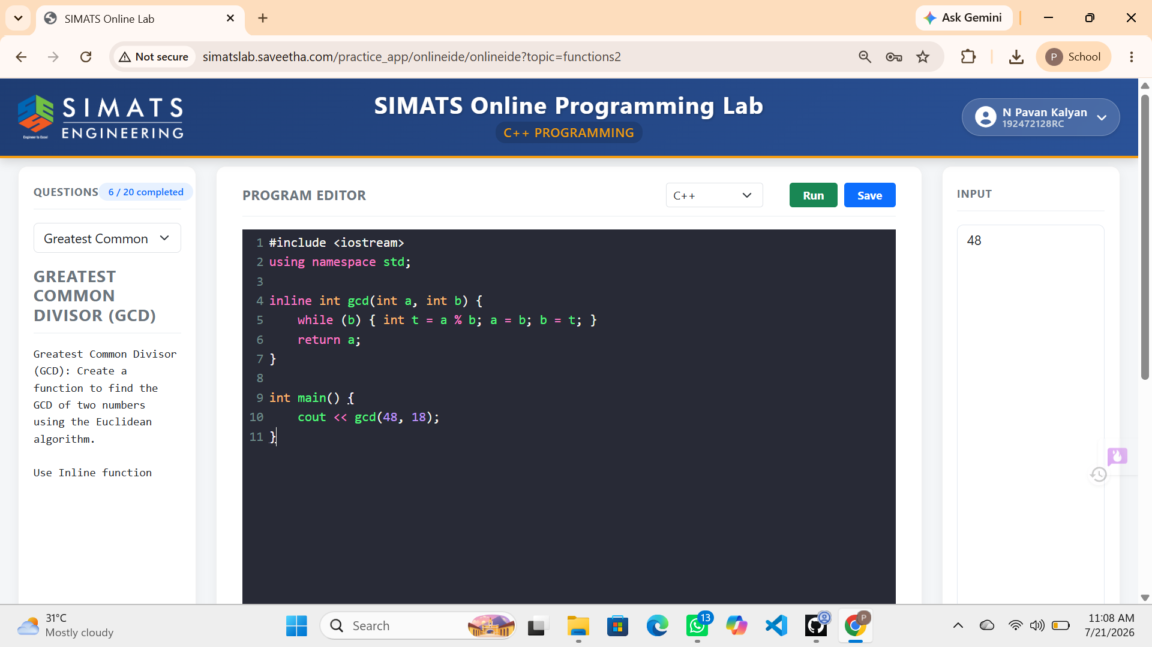

EXP:7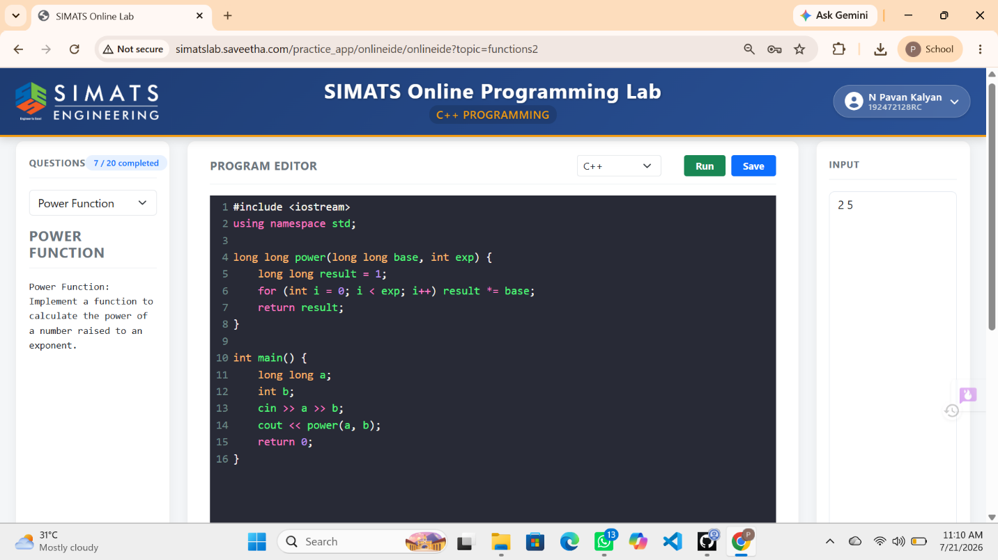

EXP:8
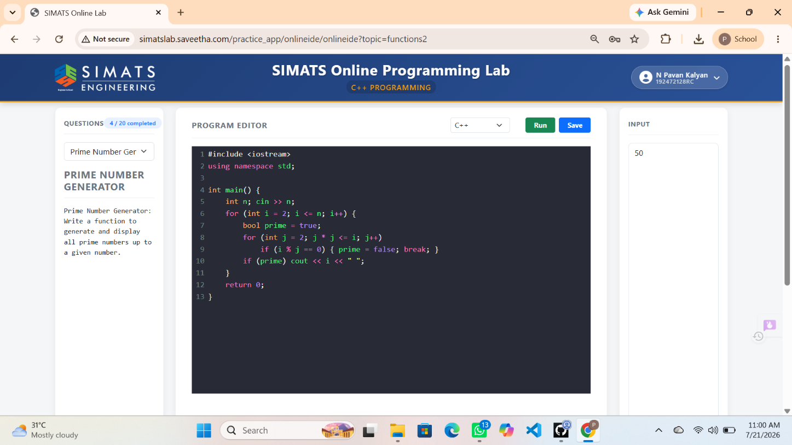
EXP:9
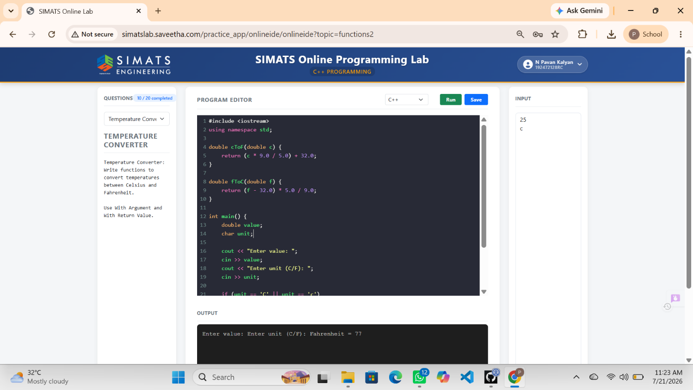

EXP: 10
